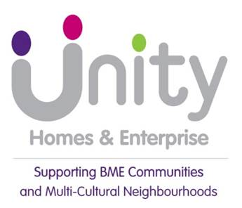

Preamble
This Strategy outlines Unity’s plans for growth through the development and acquisition of new affordable homes as described in the Corporate Plan 2021-27. The strategy covers our targets for new homes, the type of homes we want to build, the geographical areas of activity, external influences and risks to the new homes programme.
The strategy will play a key part in achieving our Corporate Plan objective to have a financially strong, viable and growing business. We aim to deliver high quality, viable and sustainable developments and services that match the values of Unity Homes & Enterprise and complement the aims in the Corporate Plan.
Hence in developing new homes, we will look to, where feasible, take advantage of opportunities to regenerate communities by improving the local infrastructure and providing opportunities for people to improve their life chances. This aligns with our social purpose:
“We will fight inequality and empower BME people to improve their lives by creating opportunities and helping to regenerate communities.”

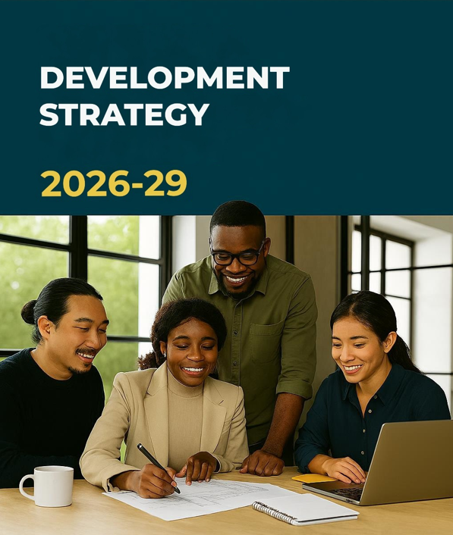
Introduction
Our vision is to improve the life chances of people born with disadvantages and living in the communities we serve. While we know our priority is our tenants, we also understand progress can only be sustained if we also create opportunities for their neighbours and invest in the regeneration of the communities they live in.
Growing our business organically is critical to realising this vision. It enables us to:
- give successive generations a good start in life with a decent home.
- provide a range of opportunities for people to enhance their prospect and change their lives.
- to invest in local infrastructure and the environmental realm.
This strategy aims to deliver organic growth through developing new homes within existing capacity and funding streams and acquiring additional stock through other means that provide value for money, such as s106 agreements, stock transfers and off the shelf purchases.
We are unable to do this on our own. Hence, we aim to continue our partnership with Homes England and the Affordable Homes Programme, with our partners in local government, in particular Leeds and Kirklees Councils and the West Yorkshire Combined Authority, and of course our consortium members.
To deliver this strategy, effectively manage risk, provide consortium members with a professional service and achieve the quality of new homes desired, we will continue to invest in staff to ensure that Unity has the appropriate resources and skills in place.
Policy Context
Alignment with Corporate Plan
This development strategy has an important role to play in helping to achieve each of the five objectives in Unity’s Corporate Plan:

- Be recognised as one of the top social landlords in West Yorkshire
- Maintain a financially strong, viable, and growing business
- Serve as a community anchor, partnering to improve lives
- Lead on Social Purpose activities, tackling inequality and inspiring others
- Be an employer of choice, nurturing talent and pride

However, its principal contribution is to ensure the business grows organically.
In addition, this strategy will help with the strategic goal for Unity “To have a reputation as a community anchor, dedicated to serving and engaging with the community and working in partnership with other agencies to improve the lives of its people”.
Equality and Diversity
We are committed to fairness and equality for all regardless of their colour, race, ethnicity, nationality, gender, sexual orientation, marital status, disability, age, religion or belief, family circumstances or offending history, as referred to in our EDI policy.
Our aim is to ensure that our policies and procedures do not create an unfair disadvantage for anyone, either directly or indirectly. We will assess the need for specially adapted properties on our new developments and will deliver these where practical, feasible and financially viable. We will consider partnerships with local community organisations and established specialist providers to help develop new affordable housing to meet unmet housing needs. We will work with several specialist external organisations to provide bespoke accommodation for those with disabilities, learning difficulties, older persons or those requiring care and support. We will continue to respond to approaches to form partnerships with organisations to meet the housing needs of those with specialist requirements and disabilities
Diversity and Equality is the Golden Thread which runs through this strategy and it intends to promote it by:
- The use of Neighbourhood Plans that include information about the diverse makeup of our areas of operation when making decisions about new developments.
- A Design Quality Framework that includes the Lifetime Homes standard which ensures all new homes provide accessible accommodation for everyone.
- Innovative proposals to look at the energy efficiency of our new developments, as a way of tackling Fuel Poverty.
- Using the learning from our work to become recognised experts in the engagement of diverse communities when working on new developments as part of our wider Corporate Plan.
- Offer our development expertise to partners to utilise their development capacity and build new affordable homes on a consultancy basis.
- Exploring new forms of public and private investment to ensure we can deliver housing which has an appropriate tenure mix that reflects the diversity of the community.
- Ensuring our development programme is used to create and promote employment and training opportunities which tackle worklessness in areas of deprivation.

Quality standard: Where do we want to be

Unity has a long-standing reputation for building quality new homes that meet customer changing expectations and we want to maintain this going forwards. Our new homes will be safe, sustainable and environmentally friendly. They will:
- Meet the current and future needs and aspirations of our customers, and be cheaper for them to run
- Be less dependent on fossil fuels, and closer to net zero carbon
- Meet EPC A as a minimum
- Meet building safety requirements regardless of height
- Be overseen by a robust inspection regime
Managing risk
Development remains one of the top three risks for Unity, so the Board depends on the Risk Appraisal Panel to carefully examine details and identify key risks in any project. Our risk appraisal model has recently been updated to consider a wider range of risks, reflecting both our recent experiences and a tougher operating environment. Nearly all major aspects of a development—such as tender prices, interest rates, and contractor reliability—now present greater risks than before. The new model ensures we properly account for these factors when assessing each scheme.
Improving communities
Unity has worked in some of the historically most deprived neighbourhoods in Leeds for nearly forty years. Originally, we thought decent housing was a sufficient springboard for most households to transform their economic and social prospects. We have learnt that it is not enough for most disadvantaged people who face other barriers. Consequently, we wholly embrace the Regeneration agenda. We want to create sustainable communities by working with people in diverse communities who are comfortable with their diversity and want to progress. Linked to this we will continue to put extra effort and resources into identifying opportunities in our priority neighbourhoods i.e. Chapeltown/Harehills and Beeston/Holbeck. Our new housing developments will support this activity as well as provide improved housing choice to meet current needs and the future aspirations of all our customers.
Customer involvement
Unity is committed to involving tenants and residents in the consultation and decision-making process. For new developments tenant/resident views will be sought at key stages through our Tenant Scrutiny Panel or bespoke surveys. The Development/Operational Teams will conduct New Homes Customer Satisfaction Surveys after residents have settled in. These surveys will ask a series of questions to cover the allocations process as well as the design, layout and build quality of their property to help gauge the overall level of customer satisfaction. We will then use this information to report to Risk Appraisal Panel (RAP) and Board to help improve our new build product and services.
Delivering and embedding Value for Money
We will ensure Value for Money is achieved in several ways as follows:
- By demonstrating the effective use of the Social Housing Grant (SHG) on our Balance Sheet
- By attracting additional ‘Other Public Subsidy’ on top our programme with Homes England. This will come from organisations such as Local Authorities, Local Economic Partnerships, West Yorkshire Combined Authority and Charities
- By maintaining a consistent downward pressure on costs via effective procurement and tendering exercises. We will review our existing frameworks for consultants and contractors to assess if we can achieve greater efficiencies and improved levels of service.
We will ensure that all relevant staff receive regular training and updates on key issues such as contract law and dispute resolution. Training plans will be continually assessed using the Skills Matrix framework in order that staff tasked with delivering the strategy have the necessary skills. Training plans will also be developed so that non-development staff, tenants and Board members have the necessary skills and knowledge to play their role in helping deliver the strategy.
We will provide regular Board updates and outturn reports when schemes are in progress, assessing financial performance, ensuring they are delivered on time and to the required quality. We will undergo Homes England Compliance Audits when selected to ensure all grant monies have been used correctly.
Key operational issues
Size and scope
Unity is a small housing association. Despite its modest size, Unity stands out by having its own in-house development team, which is uncommon for associations of this scale. This setup presents several challenges, not least an ongoing pressure to maintain a steady flow of projects to fully utilize the team’s capabilities.
The External Environment
The current Development Strategy preceded a challenging macroeconomic environment that included the impacts of Covid, reduced rental income, rising construction costs, and more contractors going out of business. Our finances have also faced considerable pressure due to increased investment to maintain safety and decency standards in our homes, and the front loading of development schemes to take advantage of time limited opportunities. Going forwards the Board has prioritised the management of our existing properties and the delivery of high-quality landlord services that address our customers’ needs. Consequently, we have recalibrated our growth objectives. Over the next 5 years we have capacity to build at least an average of 10 new homes per year. Although we hope to do more.
Local development challenges and issues
Unity has successfully secured Investment Partner Status with Homes England and delivered over 200 new homes recently, but there are increasing challenges we must contend with to continue developing.

Land Acquisition and Site Viability
- Competition for land: The financial pressures Local Authorities are facing mean LA’s are keen to get the best market price for their land. At the same time smaller associations like Unity are often outbid by private developers or larger housing associations, leaving them with only the most challenging sites. These sites may require costly remediation or demolition before development can start.
- We have limited scope to have a pipeline: We lack the scale to secure multiple sites, making us vulnerable to delays if one project stalls and having long periods of down time.

Rising Costs and Financial Constraints
- Inflation and material shortages: Since Covid Internal we have seen a 25% increase in development costs due to inflation and supply chain issues. These are compounded by a shortage of skilled labour. Moreover, there has been a marked increase in the risk of contractors going bankrupt. This happened in the first iteration of Plane Street and by the time we had secured someone to take over the cost of the development had soared well beyond the original cost budget and the grant process had to start over again.
- Funding gaps: While Homes England grant funding helps, smaller associations often need additional financial support to make marginal sites viable. We have seen delays in grant allocation and planning approvals stall projects and increase costs.
- Debt and interest rates: Interest rates are much higher than they were five years ago. This is a sector-wide problem, which mean associations face high borrowing costs and tighter margins, limiting development capacity.

Regulatory and Policy Pressures
- Priority to meet investment needs of current stock: The reintroduction of an inspection regime for the Consumer Standards emphasises RSH’s wish for developers to ensure they have resources to meet the maintenance and investment needs of their current stock before embarking on new developments.
- Compliance burden: New regulations like Awaab’s Law (requirement to keep properties to a habitable standard and undertake hazardous repairs within strict timelines) and the Social Housing Regulation Act increase operational complexity and costs.
- Energy efficiency targets: Requirements to achieve EPC ratings of C or above by 2030 add extra costs for retrofitting and sustainable design in new builds.
- Quality concerns: Sector-wide investigations have revealed issues with new-build standards (damp, mould, poor repairs), which can damage reputation and increase costs for remedial work.
New Threats and Challenges
Awaab’s Law confirms the simultaneous tightening of the requirement on social landlords to meet the investment needs of their current stock and raise health and safety standards. Safety is non-negotiable and the sector is now being asked to take urgent action to respond to issues raised by its residents.
The other key challenges the association face are:
- Increasing demand for rented and low-cost home ownership accommodation, including a significant increase in homelessness.
- Proposed changes to the planning system especially regarding a lack of capacity and skills shortages causing long delays in the process.
- Continued emphasis from the regulator on Value for Money and Risk Management, plus the strengthened role of the Housing Ombudsman and the increased emphasis on the ‘Tenants Voice’
- Implications of the devolved powers to the Regional Mayors particularly in West Yorkshire and the inter play between Leeds & Kirklees Councils, Homes England and WYCA.
- The Uk economy is experiencing modest growth with forecast predicting 1% GDP growth in 2025 and 1.9% in 2026. However, global economic uncertainty and rising labour cost are expected to dampen business investment and overall growth.
- Continued focus on climate change, reducing energy use and co2 emissions, introducing new technology and moving towards carbon neutral in new build.
- Availability of land at the right cost in the right location.

Improvements

Unity has prepared well for these development challenges
- In search of VFM Unity’s recent developments have been in Kirklees rather than Leeds where land values are lower. In the previous Development Strategy, it was agreed that Unity could develop anywhere in West Yorkshire. This being subject to it making operational sense for our staff and repairs contractors by achieving value for money and operating efficiencies. Given the current challenges it makes sense to retain our focus in West Yorkshire.
- We understand the investment needs of our current stock, with a near 100% stock condition survey and our Business Plan has made provision for us to meet those needs. We are more than halfway through the development of a sophisticated Asset Management Strategy which for the first time will allow us to include responsive repair demand in making our investment decisions. This is crucial for amongst other things reducing the risk of surprises so enabling us to invest with more confidence in new developments.
- Developing for other Housing Associations/community groups through the Unity Community Development Consortium helps us to retain our in-house development expertise whilst supporting small and fledging organisations to grow.

In-House Team and Consortium
One of the primary objectives outlined in Unity’s 2021-2027 Corporate Plan is business expansion, principally through the development of new homes. Over the past decade, Unity has maximized its financial capacity for development. Uncommonly for an organization of our size, we maintain a dedicated in-house team of two, whereas most smaller housing associations typically outsource development or acquire properties via mechanisms such as Section 106 agreements.

Historically, this approach was justified by high levels of development activity; over the last 15 years, Unity has delivered 405 new homes, averaging 27 per year. However, sustained development above our average capacity has led to a shift in circumstances, and for the next 5 years, development will be limited to an average of ten homes annually.

Ordinarily, this volume would be insufficient to fully leverage an in-house team, both in terms of workload and maintaining professional engagement for team members. For example, during 2023 and 2024, when no new schemes were directly developed, the team’s cost of £101,000 could not be capitalized and had to be absorbed as a direct expense to the revenue budget.

Anticipating these challenges, Unity established the Consortium in 2022 primarily to support smaller housing associations in maximizing their own development aspirations This initiative has additionally allowed Unity to offset in-house costs by generating fee income and optimizing team utilization. Last year, the team earned £150,000 in fees.

Since its inception, the Consortium has expanded from two to five members, with interest from two additional housing associations, indicating potential for further growth. Any significant extension would necessitate recruitment of additional development staff, which would be financed through fee income and is not expected to affect Unity’s independent development plans.

Opportunities
It is an opportunity for Unity that the government has set itself the target to build 1.5m new homes by 2029, has made £39 bn available to social landlords and is actively trying to remove barriers in planning and elsewhere to accelerate delivery.
However, whilst Unity will have some certainty re the level of income while the present Govt are in office this may change in the future.

Areas of Operation

The Association has primarily focused its activity in Leeds and Kirklees but widening that lens to include the whole of the West Yorkshire, may allow us to identify better value for money opportunities in Bradford and Calderdale etc. We have become much more knowledgeable about the development eco system in Bradford because of the work we do for Manningham there, so we are in a good position to take advantage of it going forward.

Customers now and in the future

Current Customers

Unity owns and manages 1,393 homes (@October 2025) in Leeds and Kirklees. The main concentration of stock is in Chapeltown and adjacent neighbourhoods such as Harehills, Little London, Gipton Wood and Burmantofts, which accounts for about two thirds of Unity’s accommodation. The remainder is found mainly in the Meanwood, Beeston and Crossgates. The Association has also built 38 new homes in Kirklees, with another 30 being built at Plane Street, Newsome.
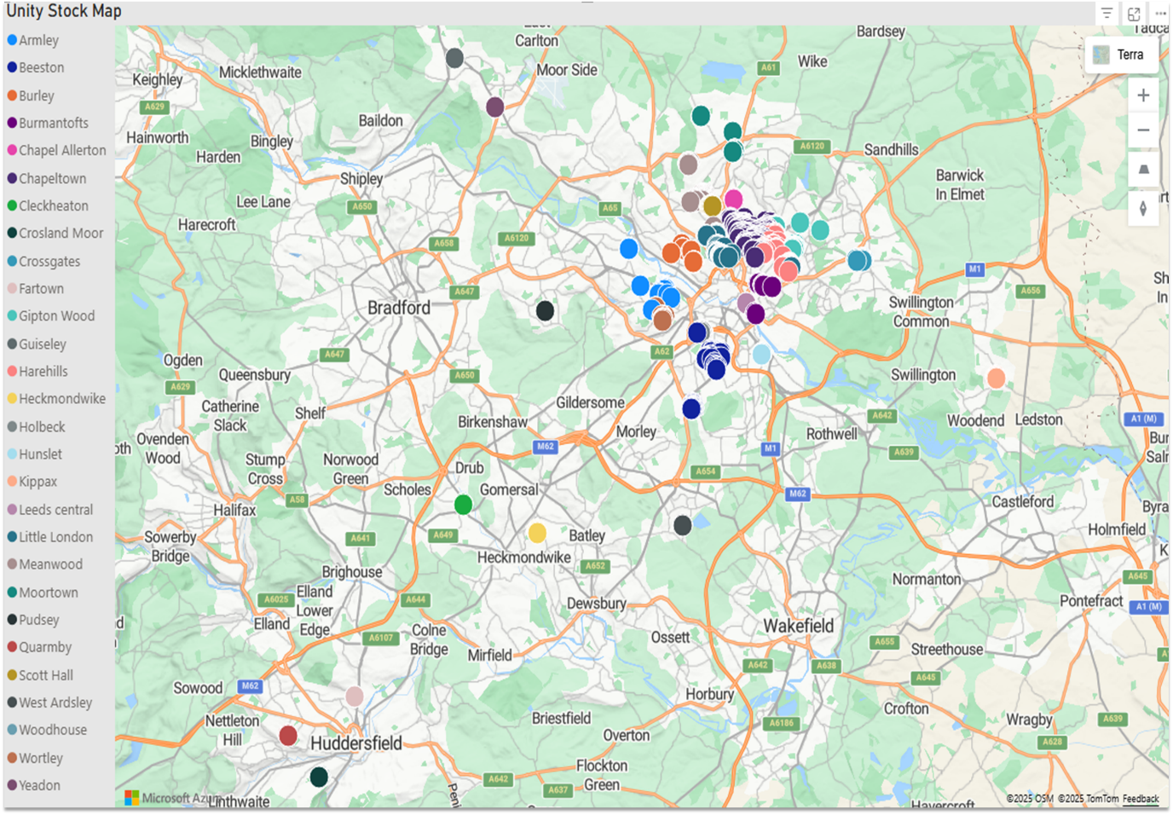

Over two thirds of Unity’s stock, is family housing, including 208 large family homes (4 Bed +), which equates to 15% of its overall stock. Although this is unusual for most housing associations it is reflective of Unity’s BME roots and its previous strategy to meet the then unmet needs of larger families, particularly from BME communities.
Unity has a very diverse ethnic mixture of customers, the largest ethnic grouping being Black at 39.3%, followed by 36.4% White, 14.4% Asian, 8.5% mixed and 1.4% describing themselves as Other 14%.

Future Customers
Between 2011 and 2021 census, the population of Leeds increased by 8.0%, from 751,500 to 812,000 in 2021 and grew again to 829,413 in 2023.
Leeds saw the third-largest percentage increase in Yorkshire and The Humber, behind Selby and Wakefield. The population of Yorkshire and The Humber increased by 3.7%, while the population of England rose by 6.6%.
In 2021, 5.6% of Leeds residents identified their ethnic group within the "Black, Black British, Black Welsh, Caribbean or African" category, up from 3.4% in 2011. The 2.1% change was the largest increase among ethnic groups in the city.
Across Yorkshire and The Humber, the percentage of people from the "Black, Black British, Black Welsh, Caribbean or African" ethnic group increased from 1.5% to 2.1%, while across England the percentage increased from 3.5% to 4.2%.
In 2021, 79.0% of people in Leeds identified their ethnic group within the "White" category (compared with 85.1% in 2011), while 9.7% identified their ethnic group within the "Asian, Asian British or Asian Welsh" category (compared with 7.8% the previous decade).
The percentage of people who identified their ethnic group within the "Mixed or Multiple" category increased from 2.6% in 2011 to 3.4% in 2021.
Leeds is clearly becoming a more diverse city with increasing numbers of people identifying with minority ethnic groups and as the lead BME Registered Provider in the city we will be able to use our expertise to support the housing needs of these growing communities by delivering services and building new homes.

The Leeds Strategic Housing Market Assessment (LSHMA) 2025 highlighted that there are 356,807 dwellings (MHCLG 2023 estimate) and a vacancy rate of 3.3%. Most dwellings are houses (69%), 5.7% are bungalows and 25.3% are flats. 57% of households are owner occupiers, 22% privately rent and 21% live in affordable housing.
In 2024, lower quartile prices for homes across Leeds was £162,500 (Yorkshire and The Humber £135,000 and England £182,500) and median prices across Leeds were £225,000 (Yorkshire and the Humber £190,000 and England £280,000). In 2024, lower quartile private rents across Leeds were £893 each month (Yorkshire and The Humber £680 and England £997) and median rents across Leeds were £1,148 (Yorkshire and The Humber £849 and England £1,573). With average income in the city being £31,400 per annum this is widening the affordability gap and making it increasing more difficult for young people and first-time buyers to access affordable housing for sale or rent.
The SHMA is predicting that the city requires 3,851 new homes per annum, this is a significant uplift on the previous average of between 3,250 – 3,400 but lower than the record high of 4,441 to March 2024 and will mean that the public and private sector will have to up their game to achieve the target. Of the 3,851 new homes required 1,518 will be an affordable tenure split as follows 53% Social Rent, 27% Affordable Rent and 20% affordable home ownership.

The Council’s Affordable Housing Strategy will continue to support the ongoing delivery of affordable housing and diversify the affordable products available to local residents to reflect identified needs but this can only be achieved in partnership with Registered Providers and the Private Sector.

Unity will continue to develop new affordable homes to meet the current and emerging needs of the communities it serves. The association will develop a range of accommodation to assist unmet need, demonstrated by the number of people on the Leeds Homes Choice based letting system.
UHA will continue to expand its development activity outside of Leeds to identify suitable affordable opportunities but ensure that it remains focussed on BME communities (although not exclusively) and that any new development can be effectively and efficiently managed to ensure VFM and operational efficiencies.

The association will also look to ensure that it develops housing for people that not only meets their housing needs but also has the wider support necessary to sustain that person in their community.
Unity will seek to develop these new homes to enable it to provide a range of housing that is sustainable in the long term, by ensuring there are a variety of options available to potential customers.

1.1 Unity Current Stock and Tenancy Profile information- October 2025
Bedroom Sizes, all stock

Count of BEDROOMS | Column Labels
Row Labels | 1 Bed | 2 Bed | 3 Bed | 4 Bed | 5 Bed | 6 Bed | Grand Total
Armley | 2 | 17 | 23 | 6 | 1 |  | 49
Beeston | 2 | 22 | 56 | 28 | 2 |  | 110
Burley | 42 | 5 | 1 |  |  |  | 48
Burmantofts | 5 | 18 | 12 | 3 |  |  | 38
Chapel Allerton | 9 | 18 |  |  |  |  | 27
Chapeltown | 110 | 127 | 57 | 74 | 13 | 6 | 387
Cleckheaton |  | 7 |  |  |  |  | 7
Crosland Moor |  | 8 | 7 |  |  |  | 15
Crossgates | 32 | 9 | 14 | 9 |  |  | 64
Fartown | 6 | 3 |  |  |  |  | 9
Gipton Wood | 10 | 10 | 31 | 12 | 5 |  | 68
Guiseley |  | 2 |  |  |  |  | 2
Harehills | 10 | 66 | 21 | 15 | 4 |  | 116
Heckmondwike |  | 2 | 12 |  |  |  | 14
Holbeck |  | 18 | 12 | 3 |  |  | 33
Hunslet |  | 6 | 5 |  |  |  | 11
Kippax | 3 | 14 | 6 |  |  |  | 23
Leeds central | 4 | 2 |  |  |  |  | 6
Little London | 15 | 52 | 28 | 2 | 4 |  | 101
Meanwood |  | 43 | 63 | 10 | 4 |  | 120
Moortown |  | 29 | 1 |  |  |  | 30
Pudsey | 9 |  |  |  |  |  | 9
Quarmby |  | 2 | 7 |  |  |  | 9
Scott Hall |  | 4 | 24 | 2 |  |  | 30
West Ardsley |  | 4 | 4 |  |  |  | 8
Woodhouse | 4 | 12 |  |  |  |  | 16
Wortley |  | 14 | 13 | 2 |  |  | 29
Yeadon |  | 1 | 3 |  |  |  | 4
Grand Total | 263 | 515 | 400 | 166 | 33 | 6 | 1383

1.2 Ethnic Origin of the Main tenant for each Ward

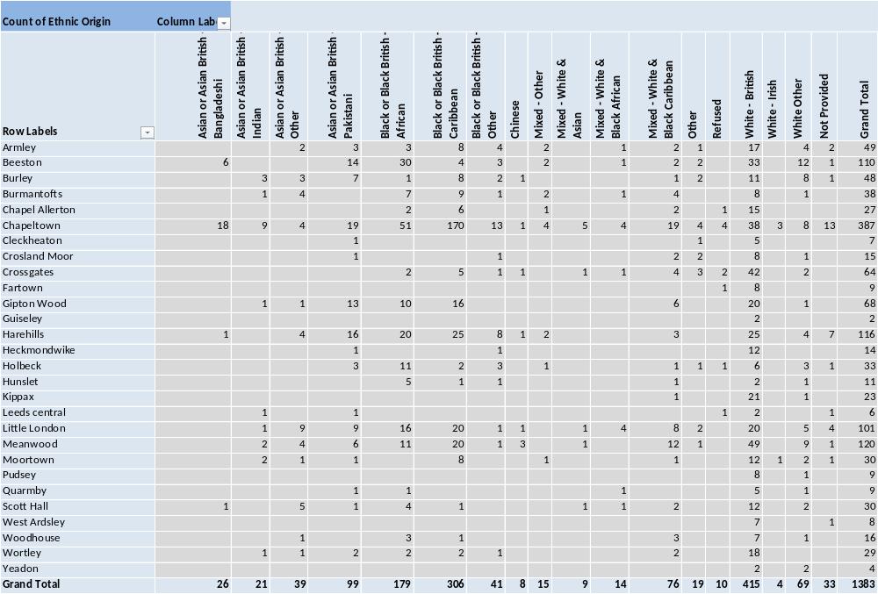

1.3 Age Range of Main tenant for each Ward

Count of Age Band | Column Labels
Row Labels | 18-25 | 26-34 | 35-44 | 45-54 | 55-64 | 65-74 | 75-84 | 85+ | Not Known | Grand Total
Armley |  | 3 | 19 | 11 | 8 | 6 | 1 |  | 1 | 49
Beeston |  | 4 | 28 | 36 | 22 | 11 | 3 | 6 |  | 110
Burley | 1 | 7 | 13 | 9 | 11 | 5 | 1 | 1 |  | 48
Burmantofts |  | 8 | 9 | 11 | 7 | 2 | 1 |  |  | 38
Chapel Allerton |  |  |  |  | 4 | 10 | 9 | 4 |  | 27
Chapeltown | 3 | 16 | 53 | 104 | 122 | 49 | 20 | 14 | 6 | 387
Cleckheaton | 1 | 3 | 2 | 1 |  |  |  |  |  | 7
Crosland Moor | 1 | 6 | 4 | 4 |  |  |  |  |  | 15
Crossgates | 2 | 6 | 7 | 17 | 17 | 10 | 5 |  |  | 64
Fartown |  |  |  |  | 3 | 5 | 1 |  |  | 9
Gipton Wood |  | 4 | 7 | 15 | 27 | 10 | 4 | 1 |  | 68
Guiseley |  |  |  | 1 |  |  | 1 |  |  | 2
Harehills | 1 | 9 | 20 | 25 | 30 | 14 | 5 | 5 | 7 | 116
Heckmondwike |  | 3 | 6 | 1 | 4 |  |  |  |  | 14
Holbeck | 1 | 4 | 11 | 8 | 9 |  |  |  |  | 33
Hunslet |  |  | 6 | 5 |  |  |  |  |  | 11
Kippax |  | 6 | 3 | 1 | 6 | 3 | 4 |  |  | 23
Leeds central |  |  | 4 | 1 |  |  |  |  | 1 | 6
Little London | 1 | 9 | 21 | 29 | 26 | 11 |  |  | 4 | 101
Meanwood | 1 | 8 | 24 | 31 | 39 | 12 | 4 | 1 |  | 120
Moortown |  |  | 4 | 8 | 9 | 4 | 2 | 2 | 1 | 30
Pudsey |  |  |  |  | 2 | 1 | 5 | 1 |  | 9
Quarmby |  | 1 | 5 | 1 | 2 |  |  |  |  | 9
Scott Hall |  | 3 | 20 | 6 |  | 1 |  |  |  | 30
West Ardsley |  | 1 | 4 | 2 | 1 |  |  |  |  | 8
Woodhouse | 1 |  | 3 | 6 | 5 | 1 |  |  |  | 16
Wortley |  | 3 | 7 | 6 | 8 | 1 | 3 | 1 |  | 29
Yeadon |  |  |  | 2 | 2 |  |  |  |  | 4
Grand Total | 13 | 104 | 280 | 341 | 364 | 156 | 69 | 36 | 20 | 1383

NB the differential between the total number of “all stock” 1407 and the directly “managed stock” 1383 equals 24. This figure arises from the fact 24 properties are currently leased or on management agreements to a number of organisations namely Latch, Canopy, Sense, Touchstone and Leeds Housing Concern.

